CREDIT CARD FRAUD DETECTION USING MACHINE LEARNING
Design and Implementation
Department of Computer Science and Engineering, TKR College of Engineering & Technology
Batch A4 (CSE-A) · Academic year [ACADEMIC YEAR]
Table 1: Project team
S.No. | Student name | Roll number
1 | ARELLI PRAVEEN KUMAR | 23K91A0513
2 | BANOTHU AJAY | 23K91A0529
3 | D CHANDRIKA | 23K91A0557
4 | BAIRAGONI VIJAY | 23K91A0525

Project guide: KOTESHWAR RAO
Chapter and section numbers quoted in the text (for example Chapter 8 or Section 6.2) refer to the full project report, 17.Final Document. Figures and tables in this document are numbered from 1.

1. DESIGN
This chapter turns the requirements of Chapter 4 into a design. It gives the architecture, the high-level workflow, the data flow diagrams, the UML models, the persistence design, the core algorithms, the module and API design, the interface design and the reasons for the main decisions. Every diagram was drawn from the code in backend/, scripts/ and frontend/src/, not from a plan, and where the code departs from good design practice the chapter says so instead of drawing an idealised picture.

1.1 Design Goals and Architecture
Four goals shaped the design. The first is a product-grade face on a research model: the base paper [1] reports training curves and sampler statistics, whereas a merchant or analyst wants a verdict, a risk band and a recommended action, so the interface speaks in business terms and keeps the model internals on a separate, clearly labelled page. The second is reproducibility on an ordinary laptop: everything runs on the CPU in numpy, needs no quantum hardware or cloud account, and regenerates its data and models from scripts. The third is graceful behaviour when something is missing: if the API is down the interface shows an offline pill and retry buttons, and if a model file is absent the API says which one. The fourth is simplicity of operation: one launcher, one configuration file for the two ports and a handful of files on disk.
The architecture has four tiers over a set of local files. The presentation tier is a React single-page application served by the Vite development server on port 5304; it has seven pages and a thin client module, lib/api.js, that wraps fetch and turns every failure into a short message that is safe to show. The application tier is a Flask 3.1 service on port 8304 that defines 16 routes (twelve in app.py and four in the read-only blueprint api_extra.py), enables CORS and converts exceptions into JSON error bodies. The model tier is a set of plain Python modules: preprocessing, the RBM classifier, the two annealing-style samplers, the training loop, the evaluation helper and the synthetic-data generator. The data tier is local files only: a CSV of 39,000 transactions, a pickled preprocessing pipeline, three pickled models, three JSON training histories and the CSV written after each bulk upload. Nothing leaves the machine; there is no external service.
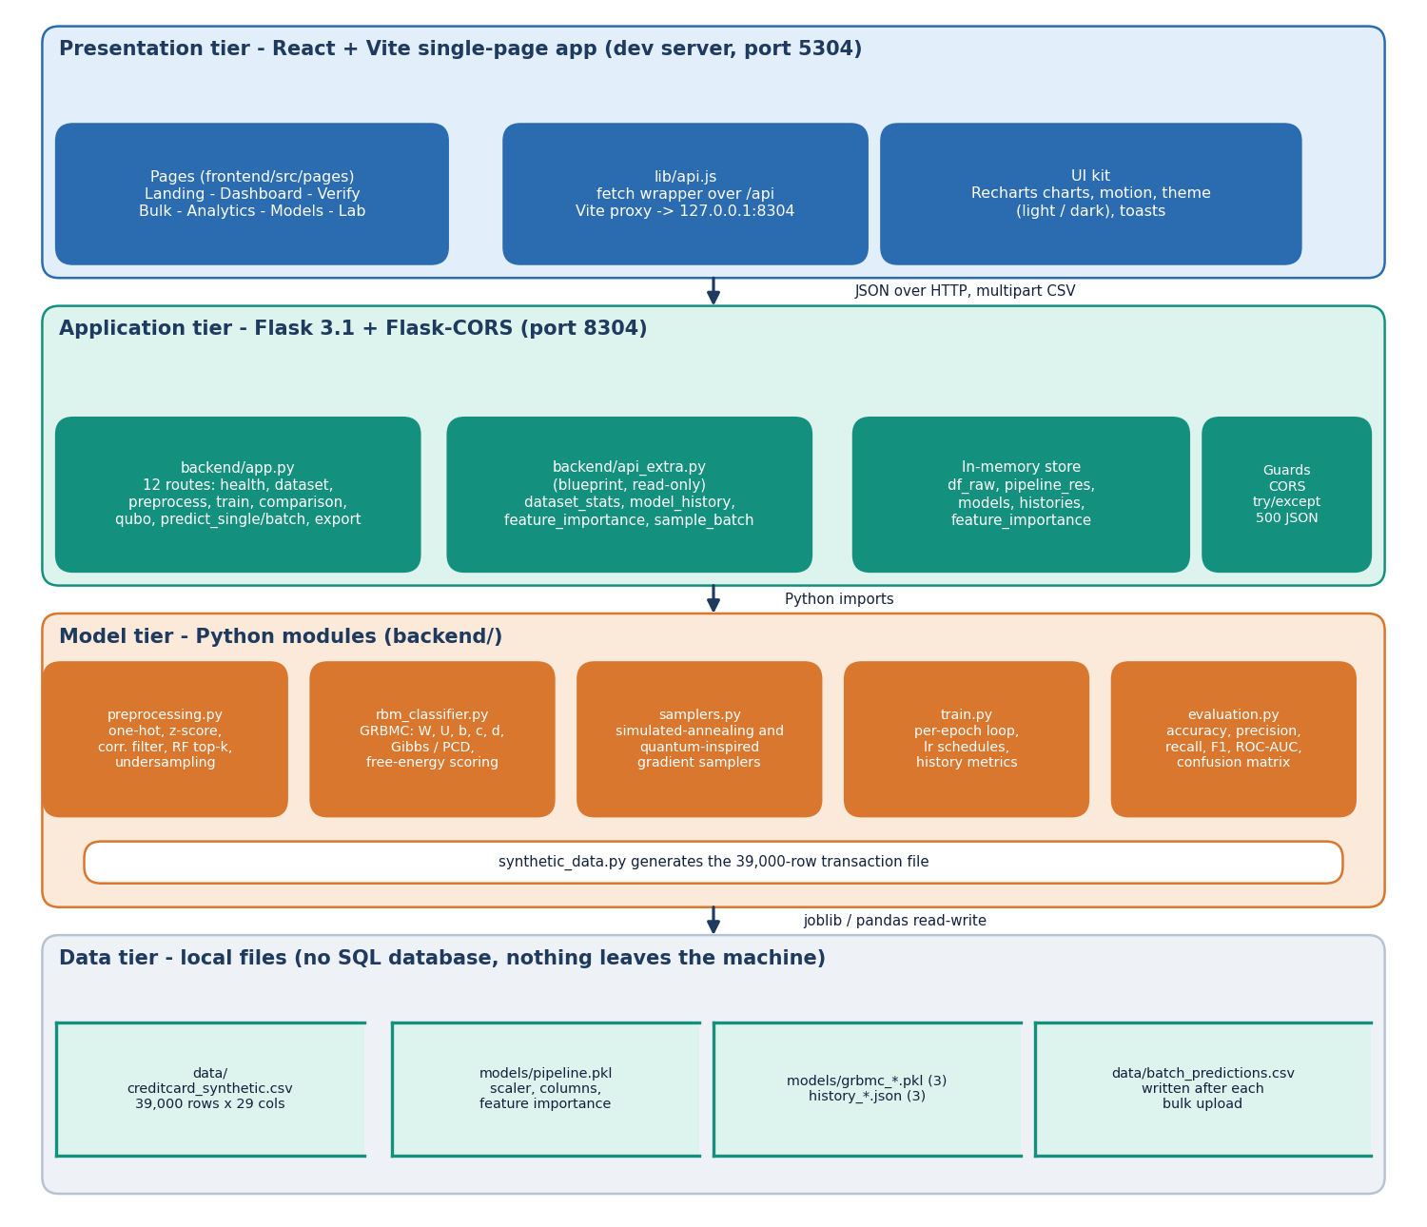
Figure 1: System architecture of SecurePay AI: four tiers over local files; there is no SQL database and no external service.
State is held in one in-memory dictionary, store, created when the Flask module is imported. It holds the raw frame, the fitted pipeline, the three models and their histories. At start-up the module loads the CSV, tries to unpickle models/pipeline.pkl, and loads whichever grbmc_*.pkl and history_*.json files exist. The design is therefore a single-process, single-user one: the dictionary is shared by all requests without locking, which is acceptable for a demonstration but would have to change before the service ran several workers.
Table 2: Tiers, technologies and responsibilities
Tier | Technology | Responsibility
Presentation | React, React Router, Vite, Recharts, Framer Motion | Seven pages, forms, tables, charts, light and dark theme, toasts, loading, empty and error states
Application | Flask 3.1, Flask-CORS | Routes, request parsing, defaults for missing fields, JSON error body, CSV upload and download
Model | numpy, pandas, scikit-learn, imbalanced-learn | Pipeline, GRBMC, samplers, training loop, metrics, synthetic data
Data | CSV, joblib pickles, JSON | Transactions, fitted pipeline, three models, three histories, batch predictions

1.2 High-Level Workflow
The system has two paths. The build path produces the models: data is generated or loaded, preprocessed, reduced to the 18 most important columns, split 80/20 and used to train the three classifiers, whose files and per-epoch histories are saved. It runs from seed_models.py or from the Model lab page. The score path uses the models: the values typed in the Verify form, or the rows of an uploaded CSV, are completed with defaults, one-hot encoded, aligned to the 18 training columns, scored by the three models, averaged and mapped to a risk band. Both paths are drawn in the figure below; the orange scaling step marks the stage that does not behave as intended and is examined in Section 5.6.
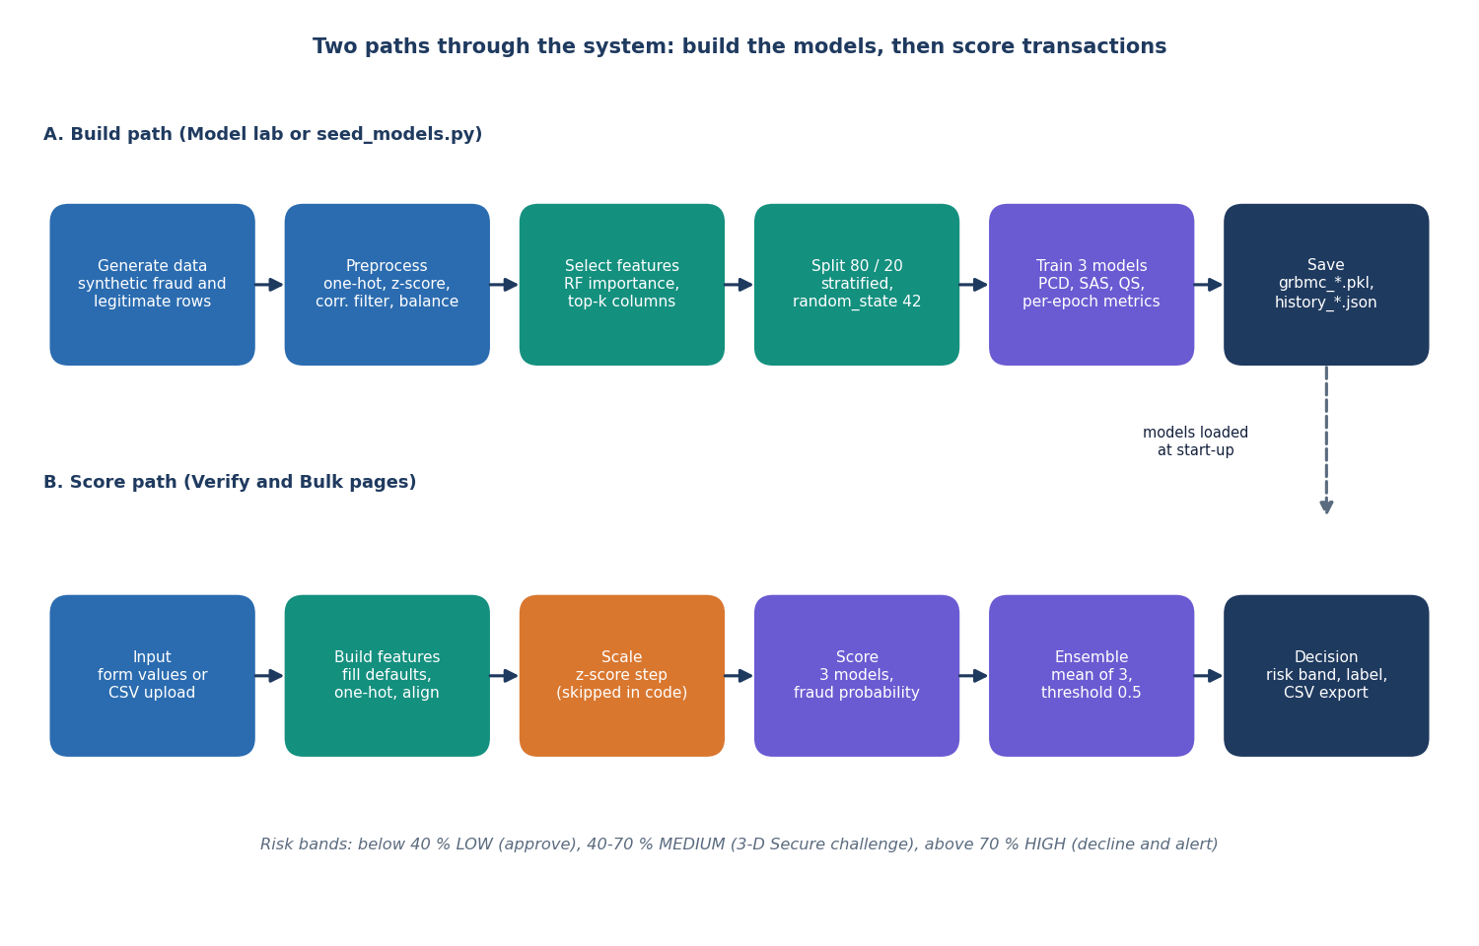
Figure 2: High-level workflow: the build path creates the model files and the score path uses them.
The two paths meet only through files and through the in-memory store. This separation keeps scoring fast, because nothing is trained while a request is served, and it lets the interface present training as an advanced, confirmed action. The interface also shows the workflow to the user in plain words on the landing page: describe the payment, prepare the features, let three models vote and get a decision band.

1.3 Data Flow Diagrams

1.3.1 Level 0: context
At the context level SecurePay AI is one process with two conceptual users and one store. A merchant or analyst sends transaction fields or a CSV file and receives a fraud score, a risk level and a decision. A risk-operations user sends retraining and viewing requests and receives analytics, model metrics and the predictions file. The application has no login, so the two roles are conceptual: they use the same screens and differ only in which functions they typically need. There is no external entity such as a payment network or a database server.
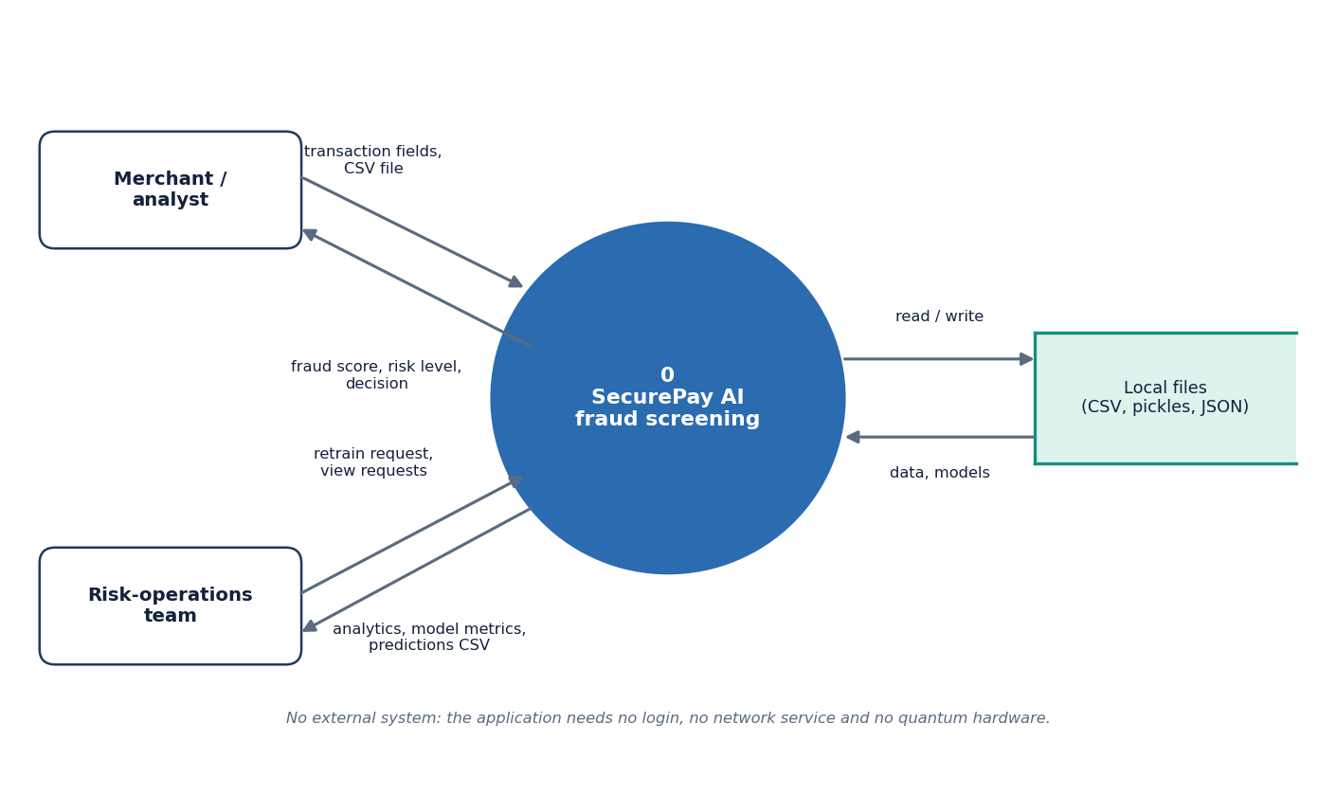
Figure 3: DFD level 0: SecurePay AI exchanges transactions, scores and reports with two kinds of user and reads and writes local files.

1.3.2 Level 1: six processes
Level 1 splits the system into six processes that correspond to groups of routes. Generating and preprocessing data (1.0) reads and writes the dataset file and produces the pipeline. Training (2.0) consumes the pipeline's train and test split and writes the model and history files. Single scoring (3.0) and batch scoring (4.0) read the pipeline and the three models. Analytics and model reports (5.0) read the dataset, histories and pipeline without changing them. Export (6.0) serves the predictions file written by batch scoring.
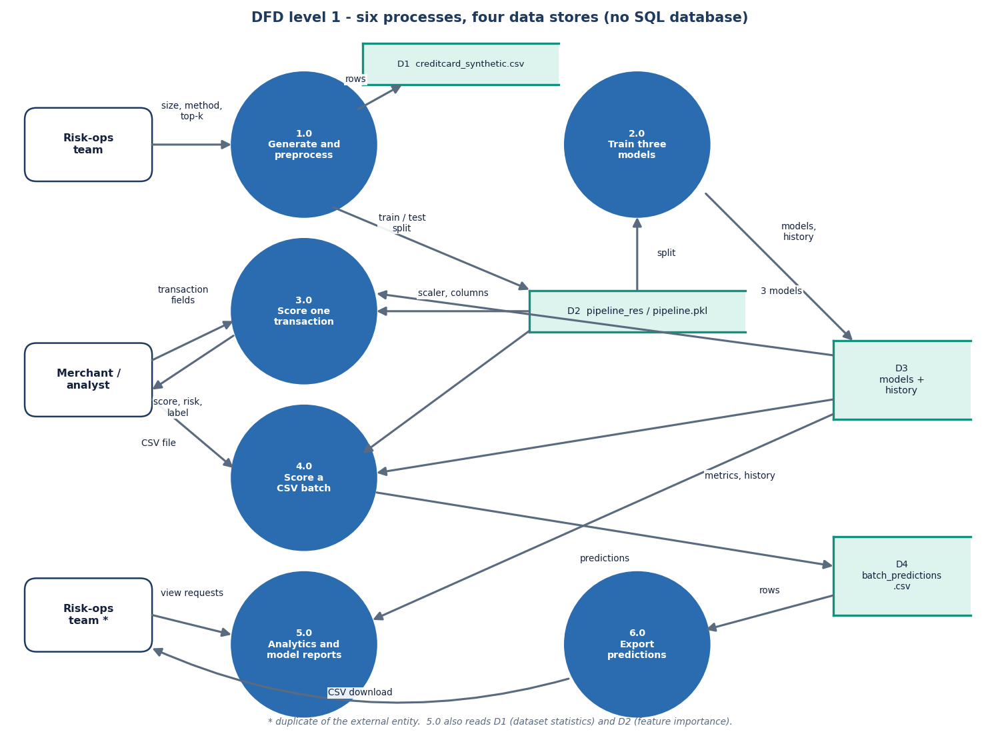
Figure 4: DFD level 1: six processes and four data stores (D1 dataset, D2 pipeline, D3 models and histories, D4 batch predictions).
Table 3: Level 1 processes
No. | Process | Routes | Reads | Writes
1.0 | Generate and preprocess data | POST /api/generate_dataset, POST /api/preprocess | D1 | D1 (new CSV), D2 (memory)
2.0 | Train three models | POST /api/train, GET /api/train_status | D2 | D3
3.0 | Score one transaction | POST /api/predict_single | D1 (defaults), D2, D3 | -
4.0 | Score a CSV batch | POST /api/predict_batch | D2, D3 | D4
5.0 | Analytics and model reports | GET /api/dataset_stats, model_history, comparison, qubo, feature_importance, dataset_info, health | D1, D2, D3 | -
6.0 | Export predictions | GET /api/export_predictions, GET /api/sample_batch | D4, D1 sample | -

1.3.3 Level 2: scoring one transaction
Level 2 expands process 3.0, the one a user meets most often. The request is validated and any missing field is filled with the dataset mean (numeric) or mode (categorical) (3.1). The two categorical fields are one-hot encoded, missing expected columns are added with value 0 and the numeric columns should be z-scored with the fitted scaler (3.2). Each of the three models returns a fraud probability (3.3), the mean is taken and compared with 0.5 (3.4), and the probability is mapped to a risk band (3.5). The note on the diagram records the defect in 3.2.
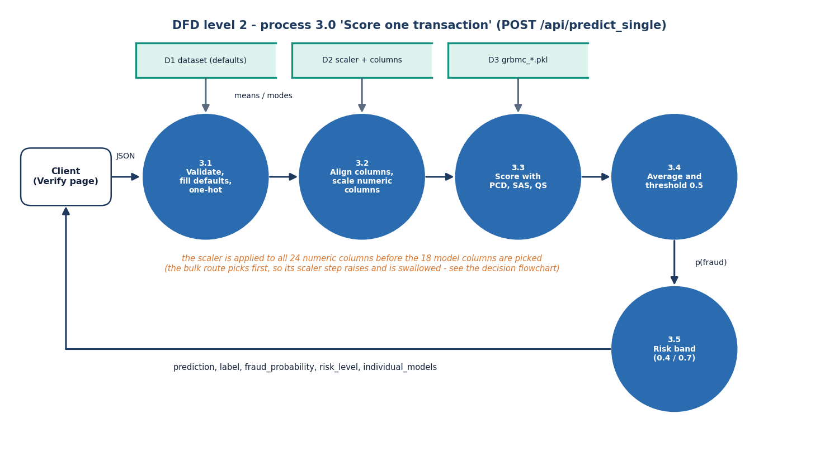
Figure 5: DFD level 2: the five steps of process 3.0, including the scaler step whose exception is swallowed.

1.4 UML Models

1.4.1 Class and module diagram
The backend is not object-oriented apart from one class. GRBMC holds the weight matrices W (visible to hidden) and U (label to hidden), the three bias vectors b, c and d, the learning rate, batch size and a persistent chain, and offers gibbs_step, pcd_step, train_epoch, predict_proba, predict and get_qubo_matrix. The other modules are collections of functions: preprocessing (one-hot, z-score, correlation filter, importance filter, three balancers and full_pipeline), samplers (the simulated-annealing and quantum-inspired gradient estimators), train (train_model and the learning-rate schedules), evaluation, synthetic_data and the Flask module with its store. The diagram draws them as stereotyped classes to show who calls whom: train creates and trains a GRBMC and calls the samplers, the Flask module owns the store and up to three models, and api_extra only reads the store.
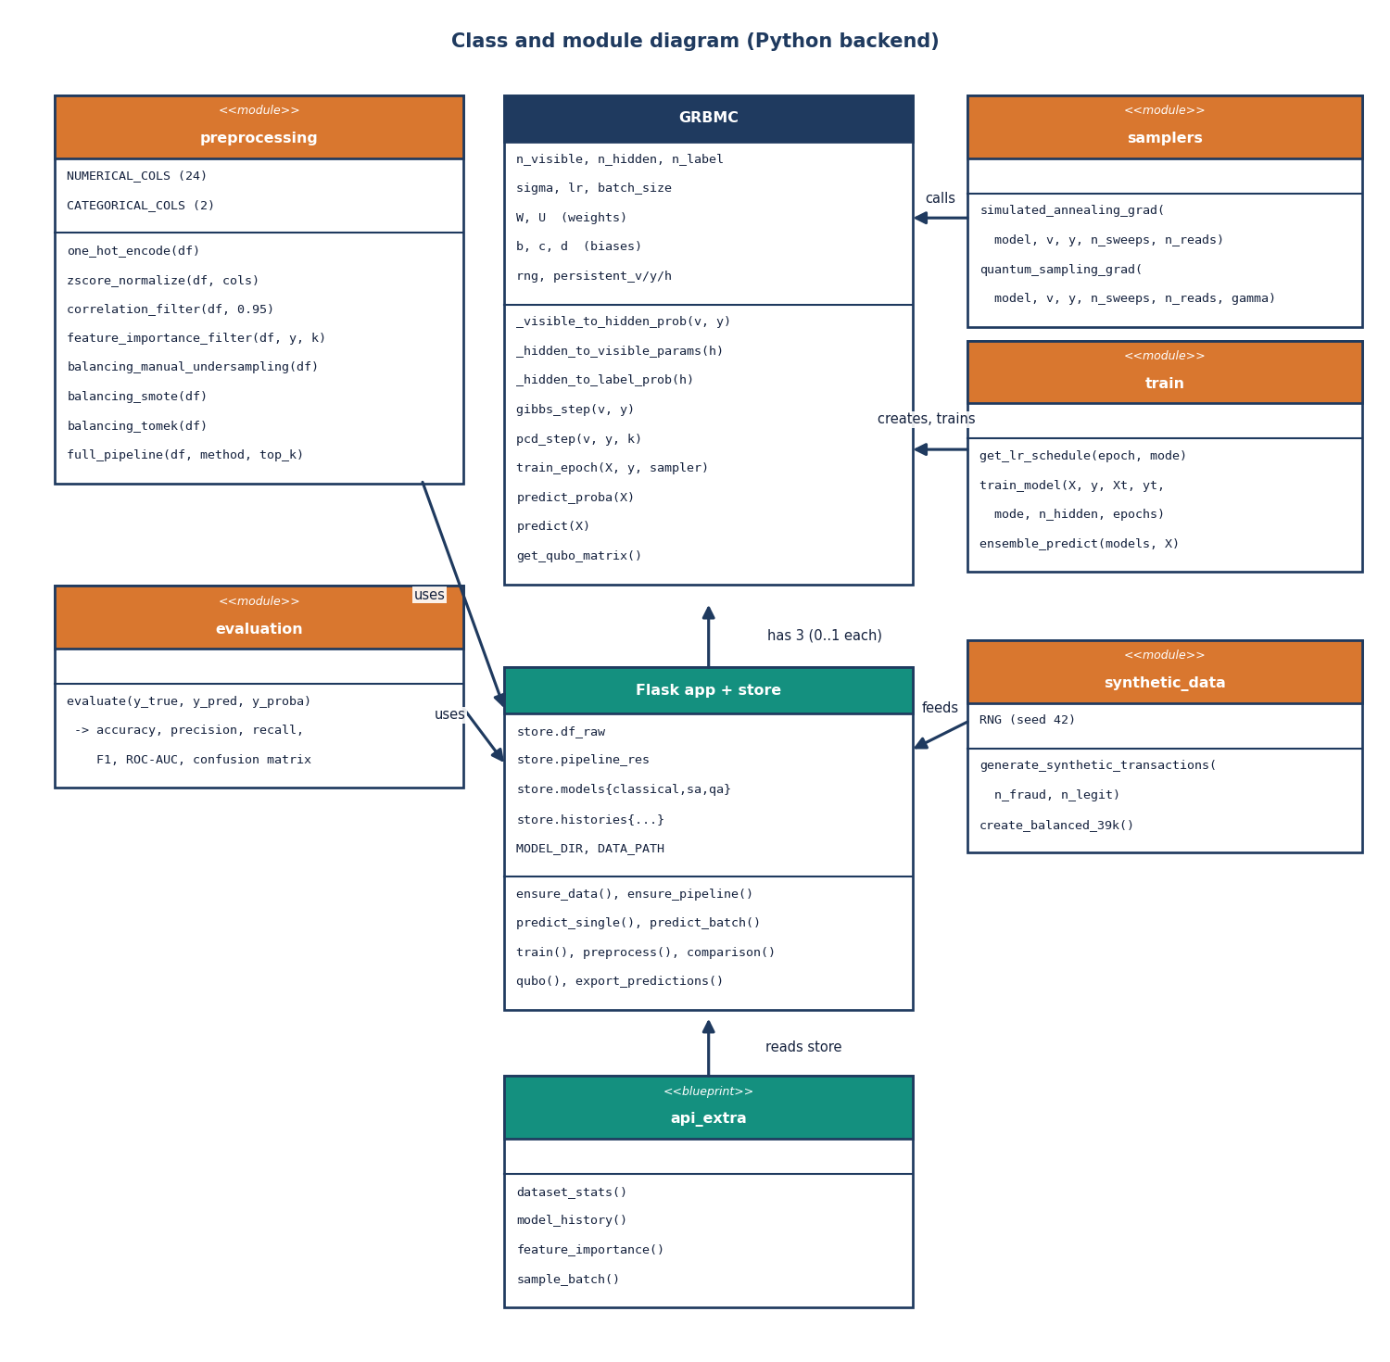
Figure 6: Class and module diagram of the Python backend: one real class (GRBMC) and the modules that create, train and serve it.

1.4.2 Sequence diagram
The sequence below follows one click on Run fraud check. The Verify page posts the form values; the Vite development server proxies the call to Flask; predict_single obtains the pipeline from the store (loading or rebuilding it on first use), builds the feature vector, asks each of the three models for predict_proba, averages the results and returns a JSON object with the prediction, label, fraud probability, risk level and the three individual probabilities. The page then draws the risk meter and the per-model bars. Measured on this PC, the API call alone (to 127.0.0.1, without the browser) has a median of 17 ms (95th percentile 32 ms).
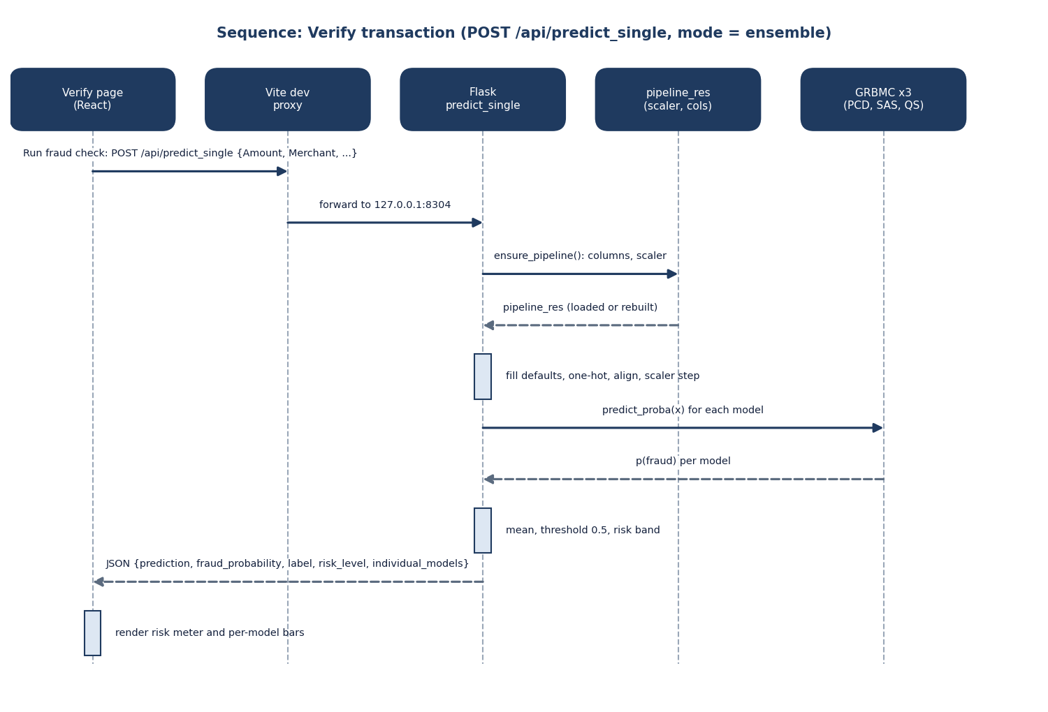
Figure 7: Sequence diagram of POST /api/predict_single with mode ensemble.

1.4.3 Use-case diagram
Seven use cases exist in the interface: verify one transaction, bulk-verify a CSV file, download the predictions, view analytics, compare models and training curves, retrain in the Model lab and download the sample CSV. The merchant or analyst role mainly uses the first three and the sample download; the risk-operations role adds analytics, model comparison and retraining. Because there is no authentication, nothing enforces this split, which is listed as a limitation in Chapter 9.
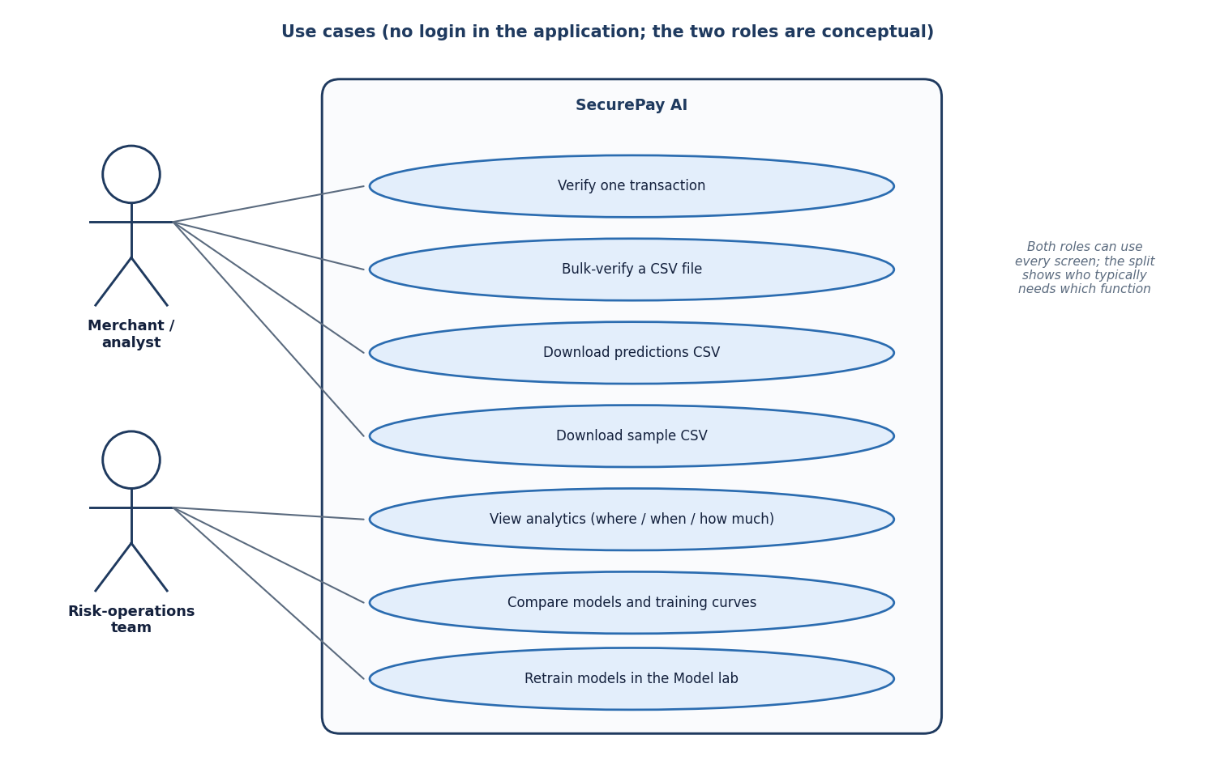
Figure 8: Use-case diagram: seven use cases and two conceptual roles; the application has no login.
Table 4: Use cases and the screen that realises them
Use case | Page | API routes used | Result
Verify one transaction | Verify | POST /api/predict_single | Verdict, probability, risk band, per-model bars
Bulk-verify a CSV file | Bulk | POST /api/predict_batch | Counts, metrics if Class is present, preview of 10 rows
Download predictions | Bulk | GET /api/export_predictions | CSV with Predicted_Class, Fraud_Probability, Risk
View analytics | Analytics | GET /api/dataset_stats | Fraud rate by merchant, channel, hour, amount, card signals
Compare models | Model comparison | comparison, model_history, feature_importance, qubo | Metrics table, curves, features, QUBO heat map
Retrain models | Model lab | generate_dataset, preprocess, train | New dataset, pipeline and three models
Download sample CSV | Bulk | GET /api/sample_batch | 20 labelled rows from the dataset

1.5 Persistence Design
SecurePay AI has no SQL database. The base paper's data is held by a fintech and is not published, and the project works on a generated file, so a relational schema would add operational cost without adding a capability. Persistence is file-based, and the 'entity-relationship' view in the figure below therefore shows files and the code paths that relate them, not tables and foreign keys.
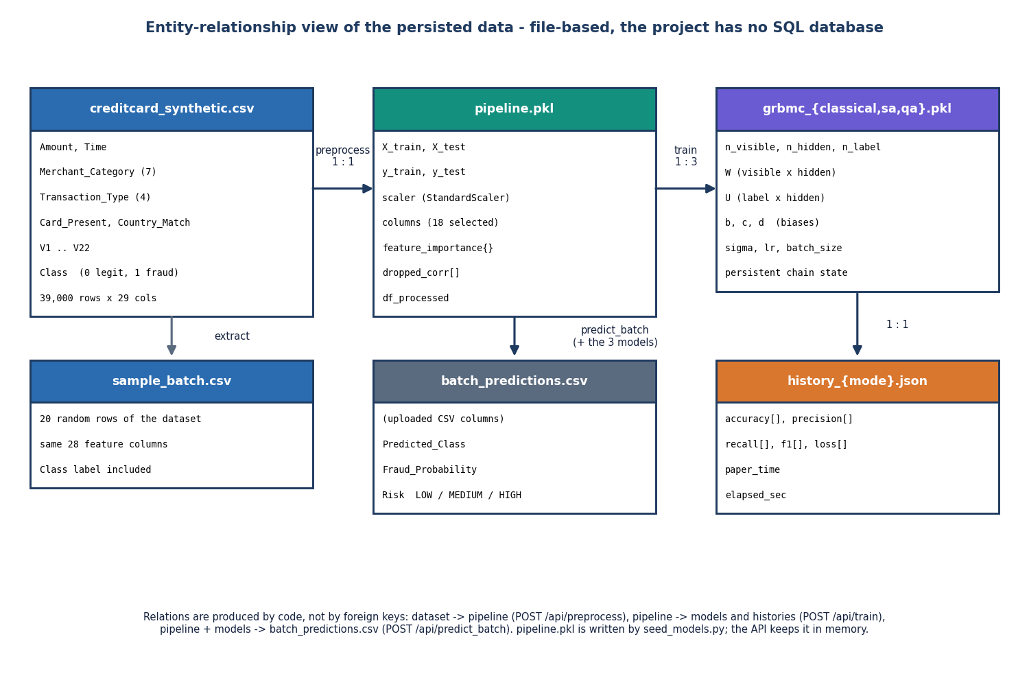
Figure 9: File-based persistence: the relations are produced by code (preprocess, train, predict_batch), not by foreign keys.
Table 5: Persisted entities
Entity (file) | Written by | Contents | Read by
data/creditcard_synthetic.csv | synthetic_data.py, POST /api/generate_dataset | 39,000 rows x 29 columns: 6 transaction fields, V1 to V22, Class | app.py start-up, analytics, preprocess
models/pipeline.pkl | seed_models.py only | X_train, X_test, y_train, y_test, fitted StandardScaler, 18 column names, feature importances | app.py start-up
models/grbmc_{classical,sa,qa}.pkl | seed_models.py, POST /api/train | GRBMC object: W, U, b, c, d, sigma, learning rate, batch size, chain state | app.py start-up, scoring, QUBO
models/history_{mode}.json | seed_models.py, POST /api/train | Per-epoch accuracy, precision, recall, F1, loss, elapsed seconds, paper time label | comparison, curves
data/batch_predictions.csv | POST /api/predict_batch | Uploaded columns plus Predicted_Class, Fraud_Probability, Risk (overwritten every upload) | GET /api/export_predictions
data/sample_batch.csv | created once from the dataset | 20 labelled rows | Bulk page, GET /api/sample_batch

The data dictionary is short. The dataset has the columns Amount, Time, Merchant_Category, Transaction_Type, Card_Present, Country_Match, V1 to V22 and Class (0 for legitimate, 1 for fraud). Merchant_Category has seven values and Transaction_Type four; Card_Present and Country_Match are 0 or 1; Time counts seconds over a three-month window; V1 to V22 are standard-normal features in which the generator shifts V3, V7, V10, V14 and V17 for fraud rows. The in-memory store mirrors the files: df_raw, pipeline_res, models, histories, columns and feature_importance.
Two consistency hazards follow from this design and are worth stating. First, pipeline.pkl is written only by seed_models.py; retraining in the Model lab replaces the pipeline in memory and rewrites the model and history files but not pipeline.pkl, so after a restart the API could pair new models with the old pipeline if the feature count had changed. The Lab page compares the feature count of a new pipeline with the one the models were trained on and warns before it is used. Second, in the environment used for the measurements in this report pipeline.pkl could not be unpickled (it was written by a different pandas version); the API handled this as designed by rebuilding the pipeline from the same 8,000-row sample with fixed random states, and the rebuilt pipeline reproduced the stored models' test results exactly, but it shows why a pickle is a fragile format for something that must survive library upgrades.

1.6 Core Algorithms

1.6.1 Building the models
The build flowchart lists the steps in the order the code runs them. The notable design choice is that balancing and feature selection happen before the train-test split, exactly as the base paper describes [1]: the random forest that ranks the features sees the rows that later form the test set. With a balanced synthetic file the effect is small, but it is a form of leakage, and the held-out figures of Chapter 8 should be read with that in mind. Inside the epoch loop the three modes differ only in the way the negative phase of the gradient is estimated, which the next subsection shows.
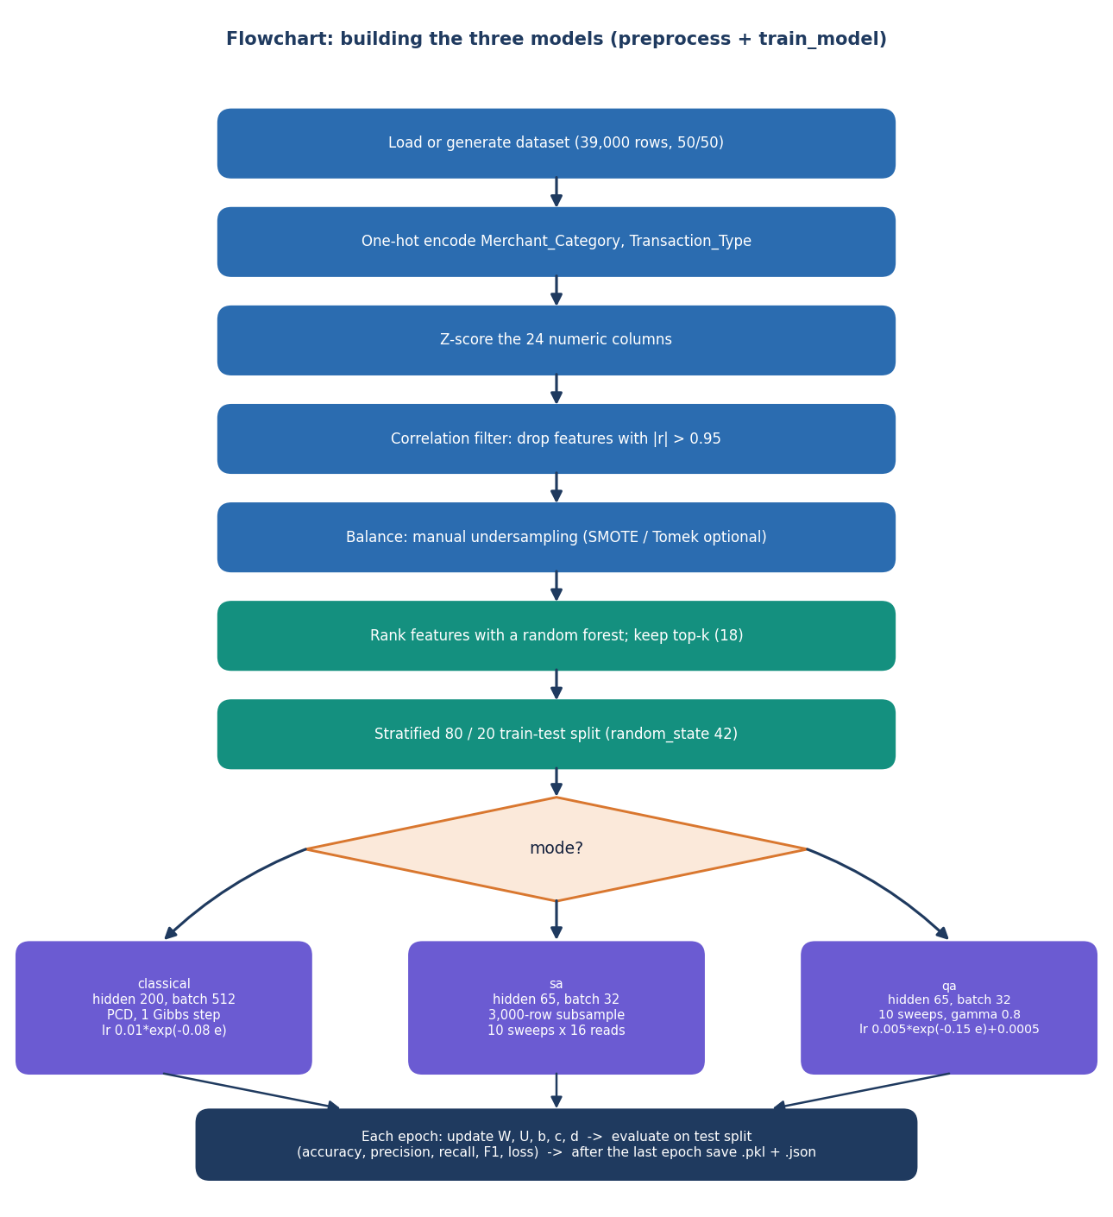
Figure 10: Flowchart of preprocessing and training: three modes share the pipeline and differ in how the model expectation is sampled.

1.6.2 The classifier and its samplers
The classifier is a Gaussian-Bernoulli restricted Boltzmann machine with a label layer. For a z-scored input vector v and a one-hot label y the hidden units are binary with p(h=1 | v, y) = sigmoid(b + vW/sigma + yU). Prediction compares the free energy of the two label hypotheses and applies a softmax, so the output is a probability of fraud. Training moves W, U, b, c and d along the difference between a data term and a model term. The data term is computed from the training batch; the model term needs samples from the model, and the three trainers obtain them differently.
ΔW = lr · ( ⟨v hᵀ⟩data − ⟨v hᵀ⟩model ) / ( batch · σ ) (1)
• Classical PCD: one Gibbs step per batch on a persistent chain, 200 hidden units, batch 512, learning rate 0.01·exp(−0.08·epoch).
• Simulated-annealing sampling (SAS): same learning-rate schedule as PCD, 16 parallel reads and 10 sweeps with an inverse temperature that rises from 0.5 to 10; the expectations are averaged over the reads, 65 hidden units, batch 32, and each epoch uses a stratified subsample of 3,000 training rows.
• Quantum-inspired sampling (QS): the same structure with a schedule s from 0 to 1, A = 0.8(1 − s) and B = s, and random tunnelling flips with probability 0.3·A; it is a classical simulation, 65 hidden units, batch 32, learning rate 0.005·exp(−0.15·epoch) + 0.0005.
It is important to be exact about what SAS and QS are. They follow the idea of the base paper's annealing-assisted training but they are a simplified approximation written for speed: the hidden field is computed from the batch-mean visible vector rather than from each row, and only a few sweeps are run. They are therefore not a reproduction of the D-Wave or path-integral samplers, and the training times measured here (a few seconds) are not comparable with the hours reported in the base paper.
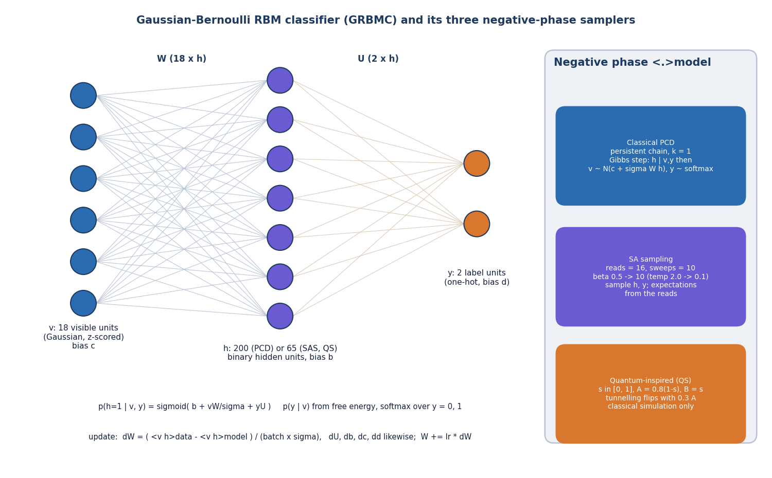
Figure 11: Structure of the GRBMC: 18 visible, 200 or 65 hidden and 2 label units, with the three negative-phase samplers.

1.6.3 Scoring and the unscaled-input defect
Scoring has to reproduce the training preprocessing exactly. The scoring flowchart fills missing fields, one-hot encodes, adds missing columns with 0, applies the fitted scaler, selects the 18 columns, collects the three probabilities, averages them and maps the mean to a band (above 0.7 high, above 0.4 medium, otherwise low; the label is fraud when the mean exceeds 0.5). The scaler step contains a defect in the bulk route only. predict_single scales the full row first and selects the 18 columns afterwards, which is correct. predict_batch selects the 18 columns first, so it calls the scaler on only the 13 numeric columns that survived feature selection, although it was fitted on all 24; scikit-learn raises an error, a bare except: pass swallows it and the models receive unscaled values. The defect was found by code review and measured: on a fresh 2,000-row batch the ensemble's accuracy is 50.2% as served and 94.8% when the same rows are scaled correctly. It is documented, not fixed, in this project; the dashed boxes in the figure show it honestly.
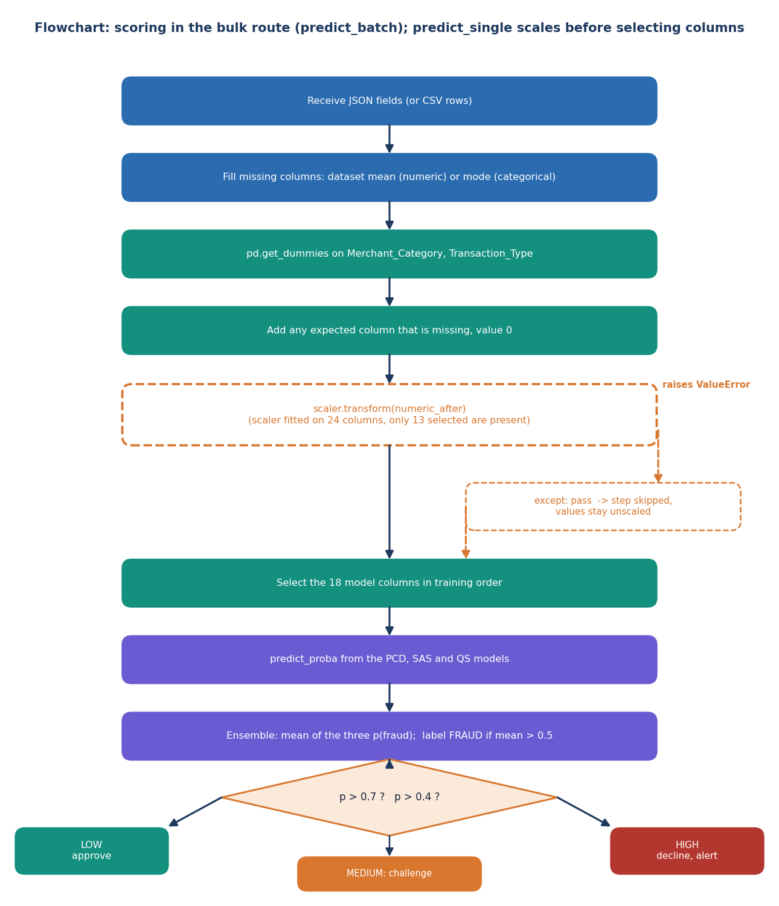
Figure 12: Flowchart of scoring in the bulk route: the dashed boxes show the scaler step that fails silently.

1.7 Module Design
The code has eleven pieces, eight backend modules and three scripts, each with one responsibility; the table lists them with their real sizes. The separation follows the data flow: preprocessing never imports the classifier, rbm_classifier knows nothing about Flask, and train is the only module that connects them. This made it possible to run the experiments of Chapter 8 by importing the modules directly and replacing one name in train, without starting the server.
Table 6: Backend modules, files, responsibilities and size
Module | File | Responsibility | Key functions | Lines
Flask application | backend/app.py | Routes, in-memory store, loading of data, pipeline and models, JSON errors | ensure_data, ensure_pipeline, predict_single, predict_batch, train, preprocess, comparison, qubo | 502
Read-only API | backend/api_extra.py | Analytics and history endpoints used by the React pages | dataset_stats, model_history, feature_importance, sample_batch | 110
Preprocessing | backend/preprocessing.py | Encoding, scaling, correlation filter, balancing, importance filter, split | full_pipeline, one_hot_encode, zscore_normalize, balancing_* | 157
Classifier | backend/rbm_classifier.py | GRBMC parameters, Gibbs and PCD steps, probability, QUBO matrix | pcd_step, train_epoch, predict_proba, get_qubo_matrix | 197
Samplers | backend/samplers.py | Annealing-style and quantum-inspired gradient estimators | simulated_annealing_grad, quantum_sampling_grad | 150
Training loop | backend/train.py | Epoch loop, learning-rate schedules, per-epoch evaluation, history | train_model, get_lr_schedule, ensemble_predict | 126
Evaluation | backend/evaluation.py | Accuracy, precision, recall, F1, ROC-AUC, confusion matrix | evaluate | 20
Data generator | backend/synthetic_data.py | Synthetic legitimate and fraud rows, balanced 39,000-row file | generate_synthetic_transactions, create_balanced_39k | 76
Seeding script | seed_models.py | Builds pipeline.pkl and the three models from an 8,000-row sample | (script) | 42
Smoke test | scripts/smoke_test.py | 20 API checks, read-only unless --full is given | (script) | 111
Screenshot capture | scripts/capture_screens.py | Playwright capture of every page | (script) | 133

The frontend adds 3,574 lines under frontend/src: seven page components (1,416 lines), a small UI kit (components/ui: buttons, cards, forms, tables, tabs, toasts, overlays, navigation), four application components (RiskMeter, ConfusionMatrix, Heatmap, MetricTiles), the API client and the theme provider. Every page is loaded lazily as its own chunk so that the charting library is fetched only when a chart page is opened. The backend has 1,338 lines in total.

1.8 API Design
The API has 16 routes, listed below with the fields read from the code. The conventions are few. Bodies and responses are JSON except for the CSV upload (multipart) and the two downloads. Successful calls return HTTP 200; a missing upload or an untrained model returns 400 or 404 with {"error": message}; any unexpected exception is caught, printed to the console and returned as HTTP 500 with the same body, which is what lets the interface show a readable message. Cross-origin requests are allowed from any origin. The Vite proxy forwards /api to port 8304, so the browser sees one origin.
Table 7: API routes
Method | Path | Purpose | Request fields | Response fields
GET | / | Legacy single-page Flask template (kept as a fallback) | - | HTML
GET | /api/health | Liveness and loaded models; drives the status pill | - | status, models_trained[], data_rows
POST | /api/generate_dataset | Regenerate the synthetic file; clears models in memory | n_fraud, n_legit (clamped 500-50,000) | rows, fraud, legit, message
GET | /api/dataset_info | Dataset size, columns, first five rows, describe() | - | rows, columns, fraud_count, legit_count, head, describe
POST | /api/preprocess | Run the pipeline on the whole dataset | method (manual, smote, tomek), top_k | columns, train_shape, test_shape, feature_importance, dropped_corr
POST | /api/train | Train the chosen modes and save files | modes[], epochs, n_hidden | per mode: history, metrics, config
GET | /api/train_status | Epoch count and best F1 per trained mode | - | per mode: epochs, best_f1, last_metrics
GET | /api/comparison | Table at each mode's best-F1 epoch; shows the paper's Table 1 if no history exists | - | Method, mode, Accuracy, Precision, Recall, F1-Score, TotalTime, best_epoch
GET | /api/qubo | QUBO matrix of one trained model | mode | shape, display_size, Q (40x40), stats; 404 if untrained
POST | /api/predict_single | Score one transaction | transaction fields or features[], mode | prediction, label, fraud_probability, risk_level, individual_models
POST | /api/predict_batch | Score a CSV (multipart field file) | file; optional Class column | rows, preview[10], fraud_detected, metrics
GET | /api/export_predictions | Download the last predictions file | - | CSV or 404
GET | /api/dataset_stats | Analytics over the full dataset | - | by_merchant, by_channel, by_hour, amount_buckets, card_present, country_match
GET | /api/model_history | Per-epoch histories of all modes | - | mode -> history
GET | /api/feature_importance | Importance ranking and selected columns | - | importance[], columns, dropped_corr, train_shape, test_shape
GET | /api/sample_batch | Download the 20-row sample CSV | - | CSV

Three design details deserve a comment. Defaults: predict_single accepts a partial transaction and fills every missing column with the dataset mean or mode, which is why the Verify form needs only nine fields although the model sees eighteen. Modes: mode may be ensemble or one of classical, sa and qa; only the ensemble answer contains the risk level and the per-model probabilities. Batch input: extra columns in an uploaded file are dropped and missing feature columns are set to 0 instead of rejecting the file, so the Bulk page checks the header itself and warns about missing columns before upload.

1.9 User Interface Design
The interface was designed as a banking risk dashboard, not as a research notebook. A calm pastel palette, rounded cards and a single accent colour keep the focus on verdicts; risk is always encoded three ways (colour, word and position on the meter) so that it is readable without colour. The landing page explains the four steps and links to the six working pages; the working pages share a sidebar, a top bar with the page title, an API status pill and a theme toggle.
Table 8: Pages and the API calls behind them
Route | Page | Content | API calls
/ | Landing | Hero, how it works, feature cards, risk signals | -
/app | Dashboard | Four KPI tiles, fraud rate by merchant, model F1 chart, sample rows, what fraud looks like | health, dataset_info, dataset_stats, comparison
/app/verify | Verify | Nine-field form, two presets, model switch, verdict, risk meter, per-model bars | predict_single
/app/bulk | Bulk | File drop, three-step progress, counts, metrics, confusion matrix, sortable preview, downloads | predict_batch, export_predictions, sample_batch
/app/analytics | Analytics | Four tabs: where, when, how much, card signals | dataset_stats
/app/models | Model comparison | Four tabs: comparison, training curves, features, QUBO matrix | comparison, model_history, feature_importance, qubo
/app/lab | Model lab | Three steps: dataset, preprocessing, training, with confirmations | dataset_info, generate_dataset, preprocess, train

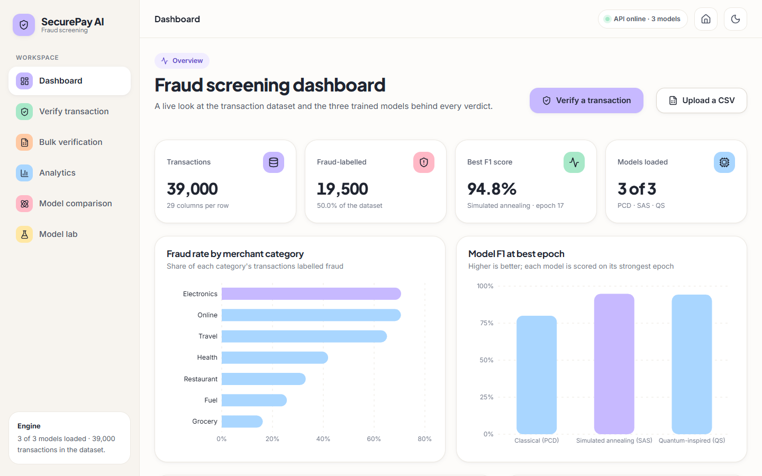
Figure 13: Dashboard: KPI tiles computed from the dataset and the loaded models, with the fraud rate by merchant and the best-epoch F1 of each model.
Dashboard. Four tiles (transaction count, fraud-labelled count, best F1, models loaded) and two charts give the overview. The F1 chart is labelled 'at best epoch', which is the base paper's convention; because the best epoch is selected on the test split the value is slightly optimistic, and Chapter 8 reports final-epoch figures as well.
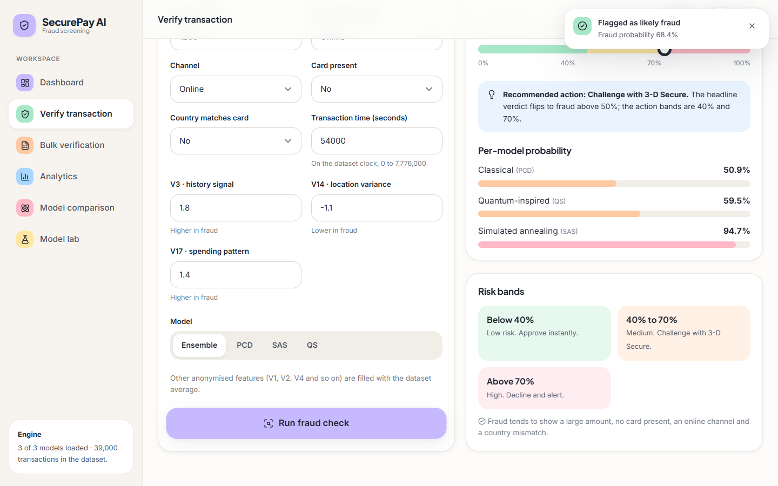
Figure 14: Verify page after a check of the large online example: probability, recommended action, per-model bars and the three risk bands.
Verify. Two presets (an everyday grocery purchase and a large online purchase abroad) fill the form so that a first-time user sees both outcomes in two clicks. Inputs are validated in the browser before any request: numbers must be numbers and amount and time cannot be negative. The verdict card shows a headline, a risk badge, the probability on a meter whose scale marks 40 % and 70 %, a recommended action and the per-model probabilities. The three anonymised features are given friendly names (history signal, location variance, spending pattern); these are labels chosen for the demonstration and the features are synthetic, so they carry no real meaning. The headline flips at 50 % while the action bands are at 40 % and 70 %, and the page says so.
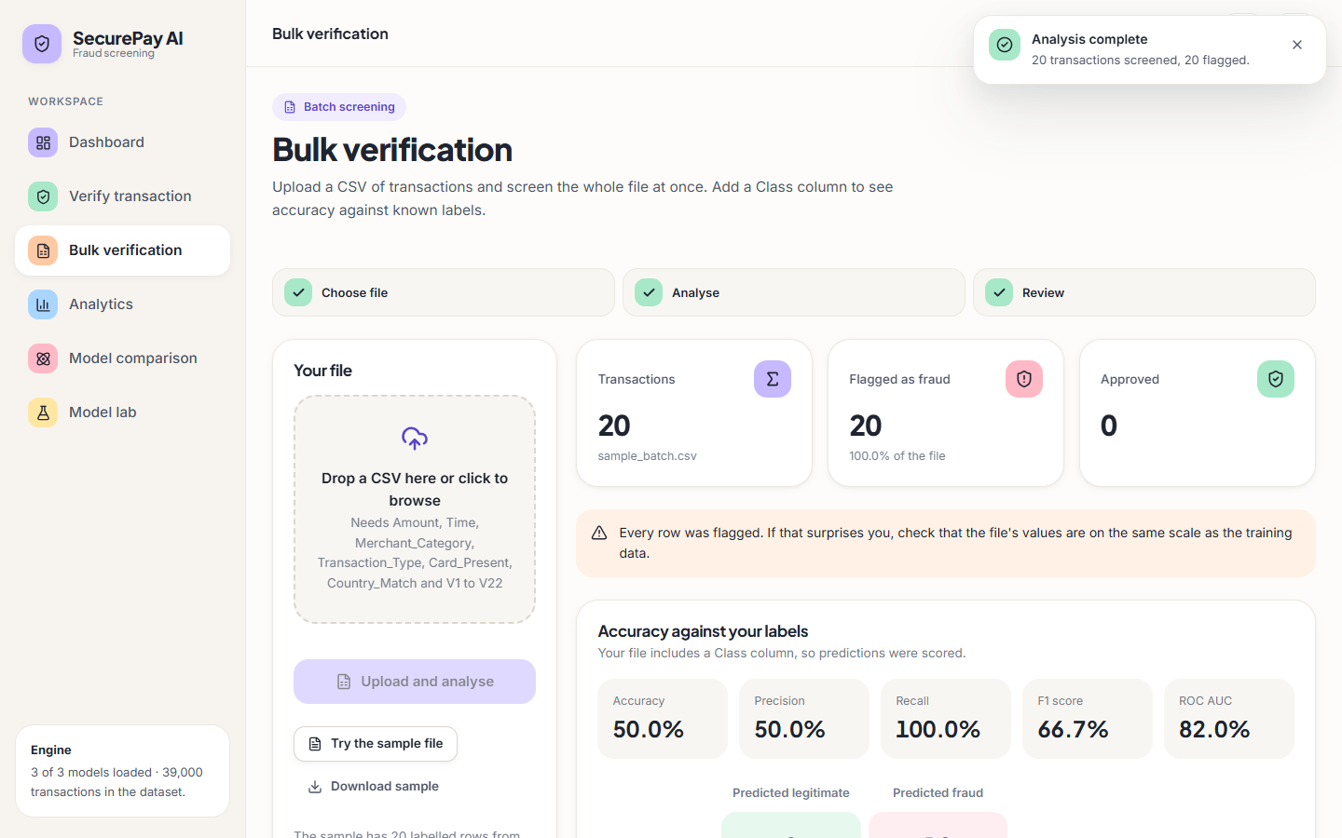
Figure 15: Bulk verification after the sample file: counts, a warning that every row was flagged, and metrics against the Class column.
Bulk. A three-step indicator, a drop zone and a 'try the sample file' button lead to counts, metrics and a ten-row preview. The page contains a safeguard: if every row of a file of five or more is flagged, a warning suggests checking that the values are on the training scale. The screenshot shows that safeguard firing on the bundled sample, which is the visible symptom of the scaling defect of Section 5.6.3.
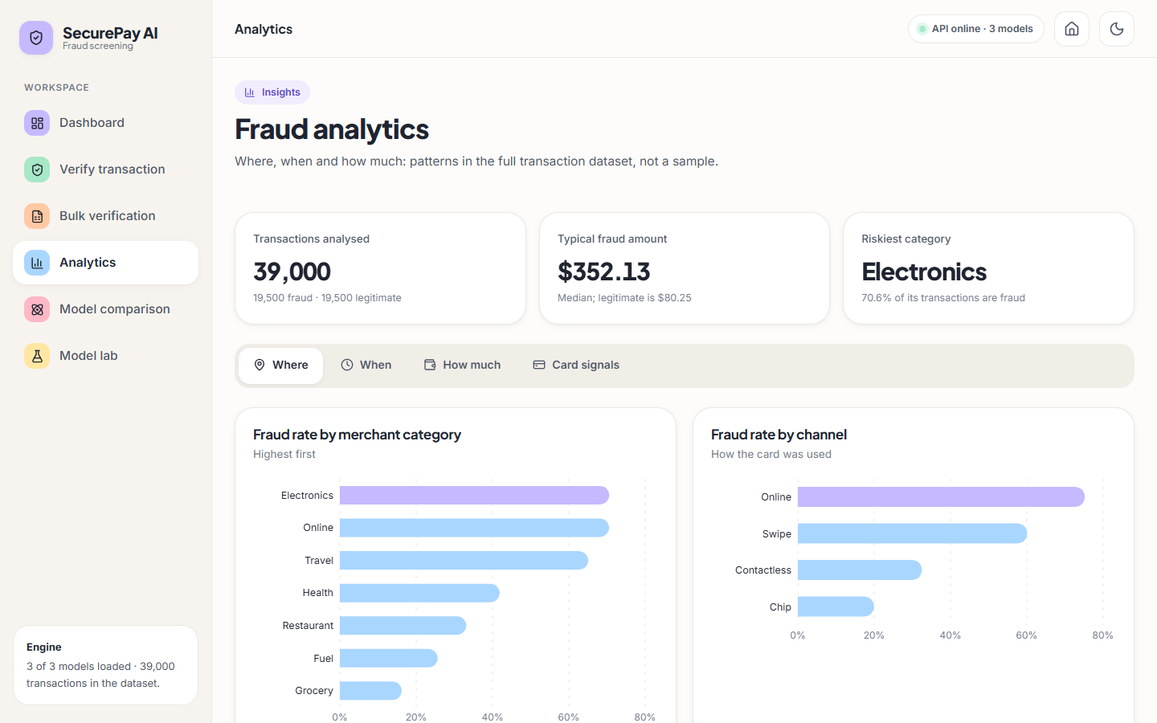
Figure 16: Analytics, 'Where' tab: fraud rate by merchant category and by channel over the full dataset.
Analytics. Four tabs answer where, when, how much and with which card signals fraud occurs, computed from the full dataset by dataset_stats. Because the data is synthetic these charts describe the generator's assumptions (for example, online and electronics purchases are made riskier by construction), not real fraud behaviour.
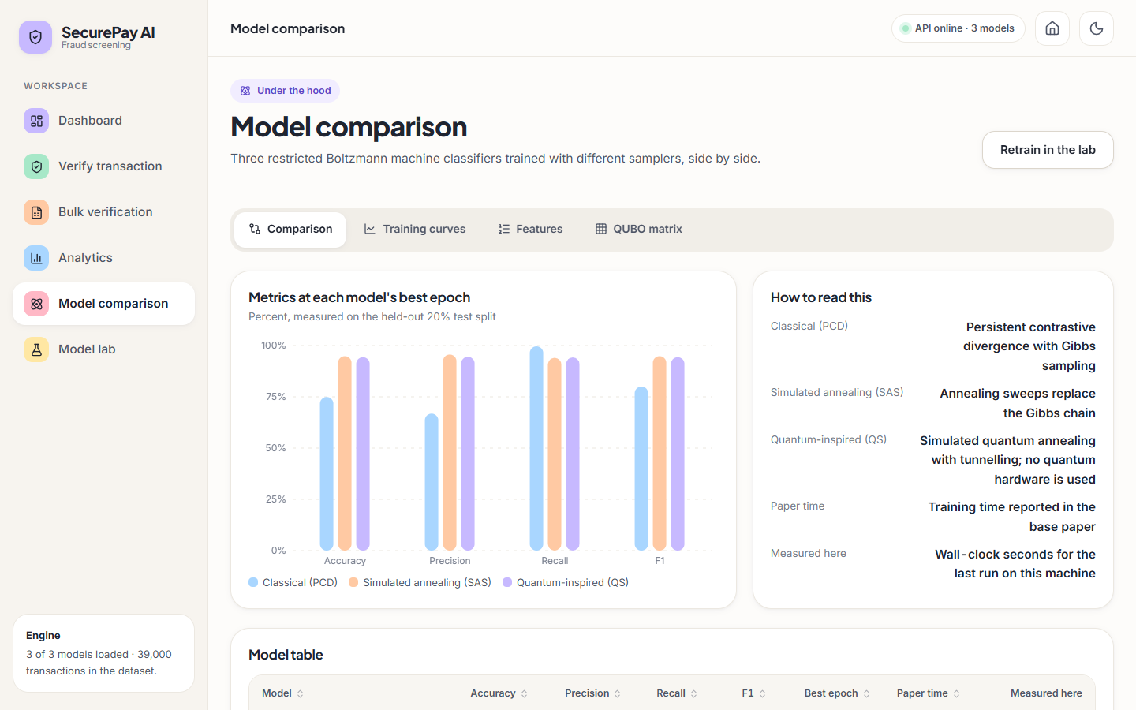
Figure 17: Model comparison: metrics at each model's best epoch and the notes that separate the paper's times from the times measured here.
Model comparison and Model lab. The comparison page shows the three trainers side by side, with a table that places the paper's training time next to the time measured on the machine, so a reader cannot mistake one for the other. Its tabs hold the per-epoch curves, the feature ranking and the QUBO heat map. The lab regenerates data, rebuilds the pipeline and retrains, with range checks on every number, a confirmation dialog before each destructive step, an elapsed-time counter and a warning when the new feature count differs from that of the loaded models.

1.9.1 Interface design decisions
• Theme: light and dark themes follow the operating system until the user toggles one; the choice is stored in localStorage inside a try block so a blocked store cannot break the page.
• Accessibility: the risk meter exposes role="meter" with its value, toasts use aria-live (role="alert" for errors), forms have labels, errors and hints, and the celebratory animation in the Model lab is skipped when reduced motion is requested.
• Offline and error states: the status pill reads 'API offline' when the health call fails, every data page offers a retry, and the client turns network failures into 'Cannot reach the API server.'
• Loading states: skeleton placeholders replace spinners so that layout does not jump, and each page is a lazily loaded chunk.
• Responsive layout: the sidebar becomes a menu on narrow screens; mobile captures of the dashboard, verify and bulk pages are in Appendix C.

1.10 Design Decisions and Trade-offs
The table collects the main decisions with the reason for each and the cost that was accepted. It includes the weaknesses a reviewer would find, because a design chapter that lists only strengths would misdescribe the system.
Table 9: Design decisions, reasons and costs
Decision | Reason | Cost accepted
Numpy implementation of the RBM | No deep-learning framework, runs in seconds on a laptop, easy to read against the paper's equations | Slower than optimised libraries; samplers are simplified approximations
Classical simulation of quantum sampling | Quantum hardware and cloud time are unavailable | Results say nothing about quantum advantage; the QS model is only quantum-inspired
Ensemble of three models, threshold 0.5 | Smooths the unstable PCD model and gives one probability and three bands | A poorly calibrated model (PCD) still pulls the mean; the 0.5 cut is not tuned
Manual undersampling to 50/50 | The base paper found SMOTE and Tomek links unhelpful at extreme imbalance | Discards most legitimate rows; the 1 % experiments of Chapter 8 show the cost in false alarms
Synthetic dataset | The base paper's data is proprietary and no public data was fixed for this project | All performance figures describe the generator, not real fraud
File-based persistence | No SQL server to run, files are easy to inspect | No transactions, shared single CSV for batch output, fragile pickles
Single-process in-memory store | Fast and simple for one user | Not safe for several workers; no locking
Broad try/except around the scaler | Intended to tolerate missing columns | Silently disables scaling, the defect measured in Chapter 8
Flask development server with debug=True, host 0.0.0.0 | Convenient auto-reload for a demonstration | Not for production: the debugger and an open host should be removed before any deployment
No authentication | Prototype scope | Anyone who can reach the port can score, retrain or overwrite the models

In summary, the design separates the build path from the score path, keeps every stage replaceable and keeps all state in a few inspectable files. Its main weaknesses, the silent scaling failure, pre-split feature selection and a shared in-memory store, are the result of prototype-level shortcuts rather than of the architecture, and each can be removed without changing the structure drawn in this chapter.

2. IMPLEMENTATION

2.1 Application architecture
SecurePay AI has three tiers. The browser tier is a React 19 single-page application built with Vite and served on port 5304; it uses react-router for seven pages, Recharts for charts and Framer Motion for transitions. Vite proxies every /api request to the application tier, a Flask 3.1 service on port 8304 (backend/app.py and the extra blueprint backend/api_extra.py). The Flask process owns the data tier: an in-memory dictionary (store) that holds the dataset, the fitted pipeline, the three models and their histories, backed by files on disk - data/creditcard_synthetic.csv, models/pipeline.pkl, models/grbmc_*.pkl and models/history_*.json. There is no SQL database.
Figure 18: System architecture: React interface, Vite proxy, Flask API, in-memory store and files on disk.
At start-up the backend loads the CSV, tries to load pipeline.pkl and, if that fails, rebuilds the pipeline from the 8,000-row sample, then loads the saved models and histories. On the development PC the saved pipeline.pkl could not be unpickled by the installed pandas (it had been written by a different pandas version), so the pipeline was rebuilt at every start; because every step is seeded this reproduces the shipped models' behaviour exactly (their metrics matched the saved histories to the last digit). A request path is React -> Vite proxy -> Flask route -> store -> response; the sequence for one scored transaction is shown below.
Figure 19: Sequence of one transaction check from the browser to the three models and back.
The React application has these pages: a landing page, the Dashboard (dataset totals, fraud rate by merchant category and best F1 per model), Verify transaction (a form that returns the risk score, the action band and per-model probabilities), Bulk verification (CSV upload with optional metrics and a download), Analytics (four tabs: where, when, how much and card signals), Model comparison (comparison, training curves, features, QUBO matrix) and the Model lab (generate data, preprocess and retrain). A health badge in the header polls /api/health every 30 seconds and an offline screen replaces the data when the API cannot be reached.

2.2 API design
The API is plain JSON over HTTP with no versioning. Sixteen routes are registered; the first twelve are in app.py and the last four are the read-only extras in api_extra.py that the React pages need.
Table 10: API routes
Method and path | Purpose | Notes
GET / | legacy single-page template | served from frontend/templates
GET /api/health | status, trained models, row count | polled by the header badge
POST /api/generate_dataset | regenerate the synthetic file | rows clamped to 500-50,000 per class; overwrites the CSV; clears models in memory
GET /api/dataset_info | row counts, columns, five sample rows, describe()
POST /api/preprocess | run the pipeline with method and top_k | returns shapes, importances, dropped columns; default top_k 22
POST /api/train | train the chosen modes for N epochs | synchronous, can take a minute; overwrites model files
GET /api/train_status | epochs and best F1 per trained model
GET /api/comparison | best-epoch table with the paper's time | falls back to the paper's Table 1 if no history exists
GET /api/qubo?mode= | QUBO matrix (top-left 40 x 40 and statistics) | 404 if the model is missing
POST /api/predict_single | score one transaction | ensemble or one model; missing fields default to dataset mean or mode
POST /api/predict_batch | score an uploaded CSV | adds Predicted_Class, Fraud_Probability, Risk; metrics when Class is present
GET /api/export_predictions | download the last batch result | 404 before the first batch
GET /api/dataset_stats | fraud rate by merchant, channel, hour, amount band, card signals | read-only, computed from the full file
GET /api/model_history | per-epoch metrics of the three models | read-only
GET /api/feature_importance | ranked importances and the selected columns | read-only
GET /api/sample_batch | download sample_batch.csv | 20 labelled rows

A single-transaction request and its response look like this (the ensemble mode is the default):
POST /api/predict_single
{"Amount": 1200, "Merchant_Category": "Online", "Transaction_Type": "Online",
"Card_Present": 0, "Country_Match": 0, "Time": 54000, "V3": 1.8, "V14": -1.1, "V17": 1.4}

200 {"prediction": 1, "fraud_probability": 0.684, "label": "FRAUD", "risk_level": "MEDIUM",
"individual_models": {"classical": 0.509, "sa": 0.947, "qa": 0.595}}

The numbers in the response are those captured in the Verify screen of Chapter 8. Errors are returned as {"error": message} with status 400 (no file uploaded), 404 (unknown or untrained model) or 500 (any exception, after the traceback is printed to the console).

2.3 Security and error handling
The application is a prototype for a controlled demonstration, and its security posture is correspondingly minimal. The table lists what exists and what does not; none of the gaps was hidden from the documentation, and the first row is a functional defect, not only a security matter.
Table 11: Error handling and security review
Area | What the code does | Consequence
Feature scaling at serving time | in predict_batch, scaler.transform is applied to the selected numeric columns only (the columns are selected before scaling); the scaler was fitted on 24, so scikit-learn raises and a bare except: pass swallows the error. predict_single scales before selecting and is correct | for bulk uploads the models receive raw Amount, V values and so on; on a fresh 2,000-row balanced batch accuracy is 50.2% as served against 94.8% when scaling is applied, and sample_batch.csv is flagged 20 of 20
Authentication and authorisation | none | anyone who can reach port 8304 can regenerate the dataset and retrain or overwrite the models
CORS | CORS(app) allows every origin | any web page can call the API from a browser
Server mode | app.run(host="0.0.0.0", debug=True) in __main__ | the Werkzeug debugger and reloader are on and the port is open on all interfaces; not for production
Upload handling | pd.read_csv(file); no size limit, no type check | a large or malformed file can exhaust memory or raise a 500
Model files | loaded with joblib.load (pickle) | a tampered pickle can run code on load, so the models/ folder must be trusted
Input validation | missing fields are replaced by dataset mean or mode; values are not range-checked | an out-of-range value is scored without complaint
Concurrency | one global store, Flask development server | concurrent training and prediction are not safe
Errors | try/except in the main routes returns JSON 500 with the message | clients see a readable error; internal paths can leak in messages
Secrets | .env holds only the two port numbers | no credentials are used; .env is git-ignored

The React client has its own handling: ApiError carries the status and the server's message, the Verify, Bulk and Lab pages show a toast on failure, the Bulk page has an explicit error state for a failed upload, and the Dashboard falls back to an API offline screen. The serving defect was found while writing this chapter, by reading the code and then confirming the result with scripts/run_experiments.py; it is documented and not fixed, in line with the project's rule that the documentation reports the code as it is. Chapter 10 lists the fix (scale with the full numeric column list, and fail loudly instead of silently).

2.4 Installation and execution
The project needs Python 3.11 and Node.js. All Python dependencies are pinned in requirements.txt: Flask 3.1.0, Flask-Cors 5.0.0, NumPy 1.26.4, pandas 2.2.2, scikit-learn 1.5.0, SciPy 1.13.0, imbalanced-learn 0.12.4, Matplotlib 3.9.0, seaborn 0.13.2, joblib 1.4.2 and openpyxl 3.1.5. The measurement scripts also use XGBoost 2.0.3, which is installed on the development PC but is not in requirements.txt because the application does not need it.
Table 12: Run steps
Step | Command | Result
1. Install Python packages | pip install -r requirements.txt | backend dependencies
2. Generate data and models (only if missing) | python backend/synthetic_data.py then python seed_models.py | 39,000-row CSV; three models; pipeline.pkl (about 45 s)
3. Start both servers | run.bat (or run.ps1) | Flask on 8304 and Vite on 5304; the browser opens
4. Or start them by hand | python backend/app.py and, in frontend, npm install then npm run dev -- --host 127.0.0.1 | same result
5. Check the API | python scripts/smoke_test.py http://127.0.0.1:8304 | 20/20 checks pass (read-only)
6. Reproduce the numbers | python scripts/run_experiments.py and python scripts/measure_latency.py | experiments/metrics.json, experiments/latency.json

Ports come from .env (BACKEND_PORT, FRONTEND_PORT), and vite.config.js reads the same file so the proxy and the servers agree. Once running, a single check takes a median of 17 ms through the Flask development server on 127.0.0.1 (95th percentile 32 ms) and a 20-row bulk upload 30 ms; addresses must use 127.0.0.1 rather than localhost on the development PC, where the name lookup adds about two seconds per call. The retraining lab is the only step that takes noticeable time, because /api/train runs inside one request.
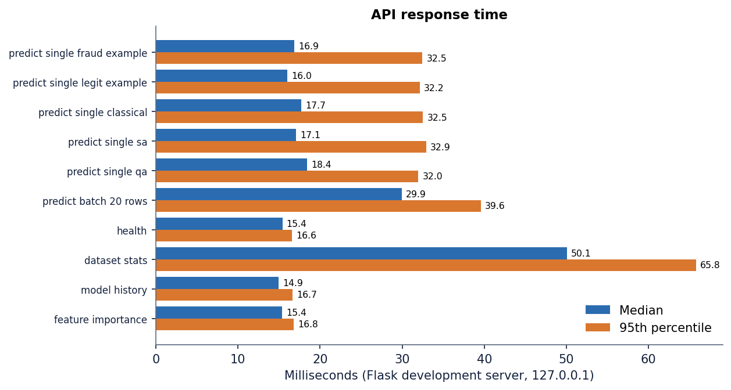
Figure 20: Median and 95th-percentile response time of the API endpoints on the development PC.

3. KEY CODE WALK-THROUGHS
Four short walkthroughs show how the central pieces work. Excerpts are copied from the repository in the state in which the results were measured.

3.1 Preprocessing: from raw rows to the 18-feature matrix
full_pipeline encodes the two categorical columns, z-scores the 24 numeric columns, drops one column of any pair correlated above 0.95 (none were dropped here), undersamples to equal class sizes and keeps the top-k features of a random-forest ranking before the stratified split. The scaler is returned so that the API can reuse it, and that is where the later defect arises.
def full_pipeline(df, method='manual', top_k=22, corr_threshold=0.95):
"""
Apply full pipeline and return X_train, X_test, y_train, y_test, scaler, feature_importance, dropped_cols
"""
# One-hot
df_enc = one_hot_encode(df.copy())
# Z-score for numeric (after one-hot numeric still there)
numeric_after = [c for c in NUMERICAL_COLS if c in df_enc.columns]
# also include binary? keep as is but scaler handles
df_enc, scaler = zscore_normalize(df_enc, numeric_after)
# Correlation filter (exclude Class)
feature_cols = [c for c in df_enc.columns if c != 'Class']
df_features = df_enc[feature_cols]
df_filtered, dropped = correlation_filter(df_features, threshold=corr_threshold)
df_filtered['Class'] = df_enc['Class'].values

# Balancing BEFORE split? Paper balances then splits 80-20
if method == 'smote':
df_balanced = balancing_smote(df_filtered)
elif method == 'tomek':
df_balanced = balancing_tomek(df_filtered)
elif method == 'manual':
df_balanced = balancing_manual_undersampling(df_filtered)
else:
df_balanced = df_filtered

# Feature importance filtering
y = df_balanced['Class']
df_final, feat_imp = feature_importance_filter(df_balanced, y, top_k=top_k)

X = df_final.drop(columns=['Class']).astype(float)
y = df_final['Class'].astype(int)

X_train, X_test, y_train, y_test = train_test_split(X, y, test_size=0.2, random_state=42, stratify=y)

return {
'X_train': X_train, 'X_test': X_test, 'y_train': y_train, 'y_test': y_test,
'scaler': scaler, 'feature_importance': feat_imp, 'dropped_corr': dropped,
'columns': list(X.columns), 'df_processed': df_final
}

3.2 The classifier: a training step and the prediction rule
The visible units are the 18 standardised features, the label is a two-unit one-hot layer, and the hidden units are binary. A persistent-contrastive-divergence step compares the data statistics (positive phase) with the statistics of a persistent Gibbs chain (negative phase) and forms the gradients of the weight matrices W (visible-hidden) and U (label-hidden) and the three bias vectors.
def pcd_step(self, v_data, y_data, k=1):
batch = v_data.shape[0]
if self.persistent_v is None or self.persistent_v.shape[0] != batch:
self.persistent_v = self.rng.normal(0,1, size=(batch, self.n_visible))
self.persistent_y = np.zeros((batch, self.n_label)); self.persistent_y[np.arange(batch), self.rng.integers(0, self.n_label, batch)] = 1
self.persistent_h = (self.rng.random((batch, self.n_hidden)) < 0.5).astype(float)

# Positive phase
pos_h_prob = self._visible_to_hidden_prob(v_data, y_data)
# Negative phase via persistent chain with k Gibbs steps
v_model, y_model, h_model = self.persistent_v, self.persistent_y, self.persistent_h
for _ in range(k):
v_model, y_model, h_model, _, _ = self.gibbs_step(v_model, y_model)
# update persistent
self.persistent_v, self.persistent_y, self.persistent_h = v_model, y_model, h_model

neg_h_prob = self._visible_to_hidden_prob(v_model, y_model)

# Gradients Eq 5-7
dW = (v_data.T @ pos_h_prob - v_model.T @ neg_h_prob) / batch / self.sigma
dU = (y_data.T @ pos_h_prob - y_model.T @ neg_h_prob) / batch
db = (pos_h_prob - neg_h_prob).mean(axis=0)
dc = (v_data - v_model).mean(axis=0) / (self.sigma**2)
dd = (y_data - y_model).mean(axis=0)

return dW, dU, db, dc, dd, (v_model, y_model)

Prediction does not sample. It computes the free energy of the input under each of the two label hypotheses and takes a softmax over their negatives, so the fraud probability is a smooth function of the weights. The visible bias term is the linear approximation noted in the comment, which is one reason the raw probabilities of the classical model are poorly calibrated.
def predict_proba(self, X):
n = X.shape[0]
# try both label hypotheses and compute free energy
# Free energy F(v,y) = -c^T v/sigma - d^T y - sum softplus(b + W^T v/sigma + U^T y)
# we compute for y=0 and y=1 and softmax over -F
y0 = np.zeros((n, self.n_label)); y0[:,0]=1
y1 = np.zeros((n, self.n_label)); y1[:,1]=1
def free_energy(v, y):
# visible term
term_v = -np.sum((v * self.c)/ (self.sigma), axis=1) # approximate
term_y = -(y * self.d).sum(axis=1)
hidden_act = self.b + (v @ self.W)/self.sigma + (y @ self.U)
term_h = -np.sum(np.log(1+np.exp(hidden_act)), axis=1)
return term_v + term_y + term_h
f0 = free_energy(X, y0)
f1 = free_energy(X, y1)
# p(y=1|v) = exp(-f1) / (exp(-f0)+exp(-f1))
# use log softmax
maxf = np.maximum(-f0, -f1)
e0 = np.exp(-f0 - maxf)
e1 = np.exp(-f1 - maxf)
prob1 = e1/(e0+e1+1e-12)
prob0 = 1-prob1
return np.vstack([prob0, prob1]).T

3.3 The simplified annealing sampler
The annealing and quantum-inspired samplers replace the Gibbs chain in the negative phase. Both start from random hidden and label samples, run a short schedule and average the result. The listing shows the core of the annealing loop. Note that the hidden field is computed from v_avg, the mean of the mini-batch, not from each row, and that the model expectation is then tiled over the whole batch; this is a large simplification of the path-integral sampling the base paper describes.
# annealing schedule
betas = np.linspace(beta_start, beta_end, n_sweeps)
for beta in betas:
# propose flip for each h_j with probability derived from energy delta (Metropolis)
# compute hidden field: b + W^T v/sigma + U^T y
# use average v_data for field approx (faster)
v_avg = v_data.mean(axis=0)
for _ in range(2): # sweeps over all hidden
field = model.b + (v_avg @ model.W)/sigma + (y_samples @ model.U) # (n_reads, n_hidden)
prob = 1/(1+np.exp(-2*beta*field)) # scaled by beta
# Flip with probability
flip = model.rng.random(h_samples.shape) < 0.05 # minor random flip then accept via prob
# simpler: sample new h from prob
h_new = (model.rng.random(h_samples.shape) < prob).astype(float)
# Metropolis acceptance: blend
h_samples = np.where(flip, h_new, h_samples)
# update y via softmax biased
logits = model.d + h_samples @ model.U.T # (n_reads, n_label)
# beta scaling
scaled = logits * beta
e = np.exp(scaled - np.max(scaled, axis=1, keepdims=True))
p = e / e.sum(axis=1, keepdims=True)
for i in range(n_reads):
if model.rng.random() < 0.3:
choice = model.rng.choice(n_label, p=p[i])
y_samples[i] = 0; y_samples[i, choice]=1

The quantum-inspired variant uses the same structure but adds a tunnelling term: with probability proportional to a transverse-field strength that decays over the sweeps, a hidden unit is reset at random instead of following the Boltzmann probability.
# A(s) = gamma*(1-s), B(s)= s . s in [0,1]
ss = np.linspace(0,1, n_sweeps)
for s in ss:
A = gamma * (1 - s)
B = s
# effective beta scaled by B, fluctuation by A
beta_eff = 0.5 + B*2.0
transverse_p = A * 0.3 # probability of quantum tunneling flip
v_avg = v_data.mean(axis=0)
field = model.b + (v_avg @ model.W)/sigma + (y_samples @ model.U)
# classical Boltzmann prob scaled by B
prob = 1/(1+np.exp(-2*beta_eff*field*B))
# add quantum tunneling: with prob transverse_p force random flip irrespective of energy
quantum_flip = model.rng.random(h_samples.shape) < transverse_p

3.4 The bulk route and the swallowed scaler error
Both prediction routes wrap the scaler call in a bare except. The single-check route builds one row with all 24 numeric columns, so the scaler works and the very first excerpt below is harmless. The bulk route first narrows the frame to the 18 model columns and only then calls the scaler, which was fitted on all 24 numeric columns, so scikit-learn raises because the columns do not match and the bare except discards the error. Because nothing is logged, the models silently receive unscaled amounts and times for every uploaded file. Measured effect on a fresh batch: accuracy 50.2% as served against 94.8% when the scaler is applied correctly.
numeric_after = [c for c in NUMERICAL_COLS if c in df_enc.columns]
# Use fitted scaler transform: scaler.mean_ / scale_
# scaler was fit on df_enc numeric before dropping etc. Use its transform on row
try:
df_enc[numeric_after] = scaler.transform(df_enc[numeric_after])
except:
pass
# Select in order
x = df_enc[columns].values.astype(float)

df_enc = df_enc[columns]
numeric_after = [c for c in NUMERICAL_COLS if c in df_enc.columns]
try:
df_enc[numeric_after] = scaler.transform(df_enc[numeric_after])
except:
pass
X = df_enc.values.astype(float)

The repair is small: transform with all of scaler.feature_names_in_ before selecting columns, and add a regression test that compares served probabilities with offline probabilities. That change was left out of this report's scope on purpose so that the measured behaviour matches the screenshots.

4. IMPLEMENTATION DECISIONS AND THEIR REASONS
The table lists the main implementation decisions with the reason for each and what it costs. Most follow the base paper; several were made for speed on a CPU.
Table 13: Implementation decisions, reasons and trade-offs
Decision | Reason | Trade-off
NumPy RBM instead of the Julia package | Runs anywhere Python runs; code can be read and tested without Julia or cloud access | Slower per step and written for clarity; fewer features than a research package
Quantum sampler simulated classically | No quantum hardware is available to the team | The result is quantum-inspired only; no hardware effects are tested
Annealing on batch mean and 3,000-row subsample | Keeps an epoch under a few seconds on a CPU | A crude approximation of the sampling in the paper; unstable QS and PCD results
Manual undersampling by default | The base paper found SMOTE and Tomek links worse on extreme imbalance; it keeps only real rows | Throws away most legitimate rows when fraud is rare
Eighteen features by random-forest importance | The paper filters by CatBoost importance to keep the model small; CatBoost is optional here | Selection before the split leaks a little test information
Z-score scaling of numeric columns | Gaussian visible units expect standardised inputs | The serving path must repeat it exactly; it currently does not
Mean of three probabilities as the ensemble | Smooths the single-model instability and gives one risk score | A poorly calibrated member (PCD) pulls the mean
Risk bands at 0.4 and 0.7 | Gives three actions: approve, challenge with 3-D Secure, decline | Not tuned on costs or validation data
Flask with plain routes and in-memory store | Smallest possible API for a prototype | No auth, no persistence, development server
React and Vite front end with a Vite proxy to port 8304 | Fast to iterate; one codebase for all screens | Needs Node.js to build and run
CSV, pickle and JSON files instead of a database | Matches the offline, file-based workflow of the base paper | No concurrent writers, no history of predictions
Final-epoch metrics as the primary result | Avoids choosing the epoch on the test split | Lower than the best-epoch values shown in the interface

